Merchant Acquiring

In this Case study , we are going to specifically look into merchant back-office applications and functionalities involved.

In this Case study , we will look at:

* What is a merchant back-office system?
* What are the typical features and functionalities of a merchant back-office system?
* Onboarding and merchant and store demographics.
* Settlement.

In this Case study , the word "store" refers to the storefront where the end transaction is being accepted. It could be an e-commerce store or a physical store.

The word "merchant" refers to the settlement entity for the stores. A single store can have a single merchant attached to it, or a group of stores can be attached to a merchant. A merchant is more like a virtual entity, whereas the store is where the actual transaction is being performed.

Now, let's look at some standard merchant hierarchies.

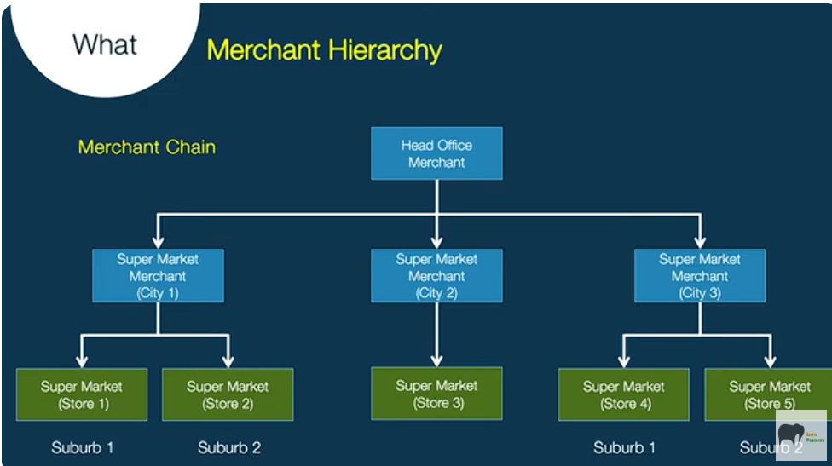

The first one is a single-store merchant, where the merchant has only one storefront.

The next one is a multi-store merchant, where one merchant has stores in various suburbs or locations. In this example, the merchant has three storefronts.

This particular slide contains an example of a typical merchant chain where a supermarket has stores in multiple cities and has about five storefronts overall in three cities. Each city can be treated as a single merchant, and all these merchants would report to a head office merchant.

Let us look at the standard functionalities of a merchant back-office system. The merchant back-office system supports merchant and store onboarding—basically, the application processing of a merchant and store.

It would support setting up a merchant hierarchy like the ones we saw in the previous slides. In the real world, there could be complex hierarchies as well.

The next function is about merchant and store demographics, which include name, address, and bank information, among others.

"Products" refers to the schemes that the merchants and stores accept. Each merchant is tagged to a set of schemes that it would accept.

Next are pricing parameters, which relate to the interchange and various fees that would be levied.

The merchant back-office system should also support transaction processing, which means accepting transactions from processing switches, posting them onto merchant and store accounts, and settling them.

Terminal management is one of the important features where the terminal IDs and the number of terminals by store and merchant are stored.

Settlement is also covered in this Case study —this refers to the actual money settlement to the merchant.

Another feature is statements—similar to the customer statements that we receive for credit cards, there are merchant statements as well.

Dispute management is another important aspect. This is related to scheme disputes, which usually require the back-office team to liaise with the store to retrieve receipts and pass them to the issuer.

Finally, the back-office system also supports the generation of reports for various business purposes.

Now, let's look at the merchant onboarding process.

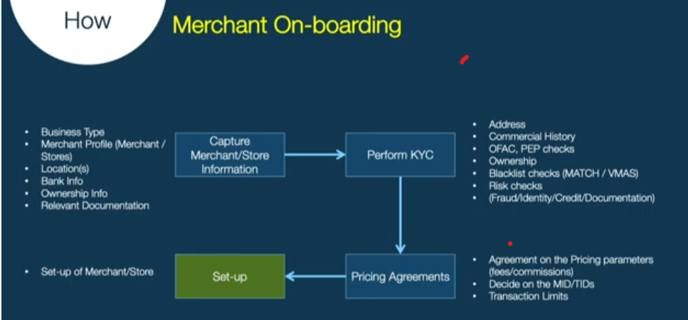

The first step in the merchant onboarding process is capturing merchant and store information.

Details that are captured include:

* **Business type**: The product or services being offered, such as a supermarket or furniture store.
* **MCC (Merchant Category Code)**: This is an important field in authorizations as it tells the issuer what type of transaction is being performed.
* **Merchant information**: Demographics, bank account information, and ownership details.

Next, the submitted details are verified. This includes verifying the address, commercial history, and ownership details of the merchant.

AML (Anti-Money Laundering) checks are also performed, such as OFAC and PEP (Politically Exposed Persons) screening, blacklist checks, and verification against MATCH (Mastercard's database) and VMAS (Visa's database) for negative merchants. Additionally, acquiring banks conduct their own risk checks.

Essentially, fraud, identity, credit, and documentation verifications are performed at this stage.

After successful verification, pricing agreements are made with the merchant based on size and transaction volume. Larger merchants may have different pricing structures compared to smaller ones. Fees and commissions are agreed upon, and MID (Merchant ID) and TID (Terminal ID) mapping is done. Transaction limits for merchants and stores are also set.

Finally, the merchant and store are set up in the merchant back-office system.

Now, let's look at typical merchant and store demographics and attributes that are stored.

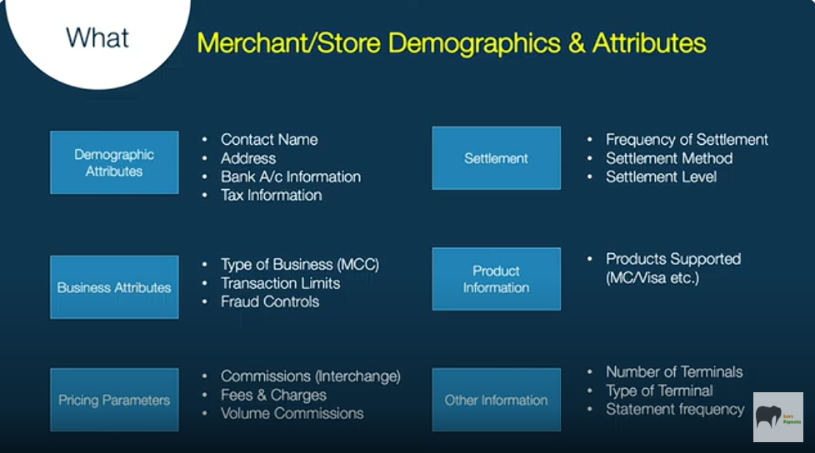

* **Demographic attributes**: These include name, address, bank account details, and tax information of the merchant.
* **Settlement information**: This includes the settlement frequency (daily, weekly, fortnightly, monthly, etc.) and the settlement method.

### **Settlement Process**

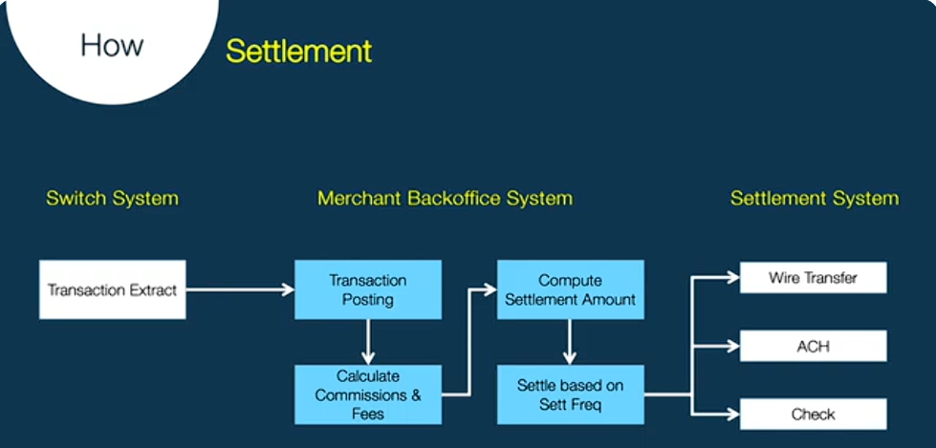

Now, let's look at a brief overview of settlement and how it happens.

Every day or multiple times within a day, the switch system sends a transaction extract to the back-office system.

The back-office system receives the file from the switching system, which operates in real-time, and then posts the transactions to the corresponding merchant.

While posting, it also computes the commissions and fees that need to be levied on the merchant.

After successfully calculating the net settlement amount, it is recorded for the merchant. Based on the agreed settlement frequency with the merchant, the funds are then disbursed to the merchant’s bank account.

The merchant back-office system sends a file to the settlement system, which may support various settlement methods like wire transfers, ACH, checks, etc.

The merchant back-office system interfaces with multiple systems such as the switching system and accounting system to receive transactions and ensure proper settlement to the merchant.

### **Merchant Back-Office System Differentiators**

1. **User Interface for Merchants**
   * Provides an interface for merchants to access and manage their data.
2. **Interface Support**
   * Settlement
   * Statement Schemes
3. **Analytics Support**
   * Helps merchants analyze transactions and performance.
4. **Support for Various Merchant Hierarchies**
   * Allows different levels of merchant structures for better organization.
5. **Commission/Rate Types**
   * Supports both flat and variable commission structures.

### **Conclusion**

* The study explored the functionalities of a merchant back-office system, including:  
  + Merchant onboarding
  + Transaction processing
  + Settlement
  + Reporting
* A well-structured back-office system ensures:  
  + Efficient fund settlements
  + Enhanced merchant operations

A good merchant back-office system provides these additional features in addition to the standard functionalities written earlier.

**Conclusion**

In this case study, we explored the functionalities of a merchant back-office system, including onboarding, transaction processing, settlement, and reporting. A well-structured back-office system ensures seamless merchant operations, efficient fund settlements, and enhanced compliance with regulatory standards.